**INDEX**

|  |  |  |  |  |
| --- | --- | --- | --- | --- |
| **Practical No.** | **Practical** | **Date** | **Page No.** | **Sign** |
| 1. | Configure IP SLA Tracking and Path  Control Topology | 01/03/24 |  |  |
| 2. | Using the AS_PATH Attribute | 07/03/24 |  |  |
| 3. | Configuring IBGP and EBGP  Sessions, Local Preference, and MED | 14/03/24 |  |  |
| 4. | Secure the Management Plane | 21/03/24 |  |  |
| 5. | Configure and Verify Path Control  Using PBR | 28/03/24 |  |  |
| 6. | IP Service Level Agreements and  Remote SPAN in a Campus  Environment | 04/04/24 |  |  |
| 7. | Inter-VLAN Routing | 12/04/24 |  |  |
| 8. | Simulating MPLS environment | 18/04/24 |  |  |
| 9. | Simulating VRF | 25/04/24 |  |  |

Practical 1

Aim: Configure IP SLA Tracking and Path Control

Topology:

R1 CONSOLE

Conf t hostname R1

interface Loopback 0

description R1 LAN

ip address 192.168.1.1 255.255.255.0

interface Serial1/0

description R1 ◻ ISP1

ip address 209.165.201.2 255.255.255.252

clock rate 128000

bandwidth 128

no shutdown

interface Serial1/1

description R1 ◻ ISP2

ip address 209.165.202.130 255.255.255.252

bandwidth 128 no shutdown

Router ISP1 (R2) CONSOLE

Conf t

hostname ISP1

interface Loopback0

description Simulated Internet Web Server

ip address 209.165.200.254 255.255.255.255

interface Loopback1

description ISP1 DNS Server

ip address 209.165.201.30 255.255.255.255

interface Serial1/0

description ISP1 ◻ R1

ip address 209.165.201.1 255.255.255.252

bandwidth 128

no shutdown interface Serial1/2

description ISP1 ◻ ISP2

ip address 209.165.200.225 255.255.255.252

clock rate 128000

bandwidth 128

no shutdown

Router ISP2 (R3) CONSOLE

conf t

hostname ISP2

interface Loopback0

description Simulated Internet Web Server

ip address 209.165.200.254 255.255.255.255

interface Loopback1

description ISP2 DNS Server

ip address 209.165.202.158 255.255.255.255

interface Serial1/1

description ISP2 ◻ R1

ip address 209.165.202.129 255.255.255.252

clock rate 128000

bandwidth 128

no shutdown

interface Serial1/2

description ISP2 ◻ ISP1

ip address 209.165.200.226 255.255.255.252

bandwidth 128

no shutdown

Step 2

R1 CONSOLE

end

show interfaces description | include up

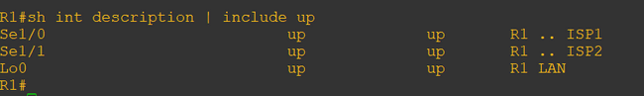

ISP1 CONSOLE

end

show interfaces description | include up

ISP2 CONSOLE

End

show interfaces description | include up

Step 3

R1 CONSOLE

conf t

ip route 0.0.0.0 0.0.0.0 209.165.201.1

ISP1 CONSOLE

Conf t

router eigrp 1

network 209.165.200.224 0.0.0.3

network 209.165.201.0 0.0.0.31

no auto-summary

ip route 192.168.1.0 255.255.255.0 209.165.201.2

ISP2 CONSOLE

conf t

router eigrp 1

network 209.165.200.224 0.0.0.3

network 209.165.202.128 0.0.0.31

no auto-summary

ip route 192.168.1.0 255.255.255.0 209.165.202.130

Step 4

ISP1 CONSOLE

exit conf t

ip route 192.168.1.0 255.255.255.0 209.165.201.2

end

ISP2 CONSOLE

exit conf t

ip route 192.168.1.0 255.255.255.0 209.165.201.2

end

Step 5

R1 CONSOLE

tclsh

foreach address { 209.165.200.254

209.165.201.30

209.165.202.158

}

{ ping $address source 192.168.1.1}

Exit

Conf t

ip sla monitor 11

type echo protocol ipIcmpEcho 209.165.201.30

frequency 10

exit

ip sla monitor schedule 11 life forever start-time now

exit

show ip sla monitor configuration 11

Conf t

ip sla monitor 22

type echo protocol ipIcmpEcho 209.165.202.158

frequency 10

exit

ip sla monitor schedule 22 life forever start-time now

exit

show ip sla monitor configuration 22

show ip sla monitor statistics

Step 6

R1 CONSOLE

Conf t

no ip route 0.0.0.0 0.0.0.0 209.165.201.1

ip route 0.0.0.0 0.0.0.0 209.165.201.1 5

show ip route

Step 7

R1 CONSOLE

conf t

track 1 rtr 11 reachability

delay down 10 up 1

exit

exit

debug ip routing conf t

ip route 0.0.0.0 0.0.0.0 209.165.201.1 2 track 1

conf t

track 2 rtr 22 reachability

delay down 10 up 1

exit

exit

debug ip routing conf t

ip route 0.0.0.0 0.0.0.0 209.165.202.129 3 track 2

exit

show ip route

Step 8

ISP1 CONSOLE

conf t

interface loopback 1

shutdown

R1 CONSOLE

show ip route

show ip sla monitor statistics

trace 209.165.200.254 source 192.168.1.1

ISP1 CONSOLE

no shutdown

R1 CONSOLE

show ip sla monitor statistics

Show ip route

Practical 9

Aim: Simulating Virtual Routing and Forwarding (VRF) environment

Topolgy

Step 1:- Prepare the routers for the lab.

Cable the network as shown in the topology diagram. Erase the startup configuration and

reload each router to clear previous configurations.

Step 2:- Configure Virtual Routing and Forwarding.

Router R1 Console

ip vrf cust-A

exit

ip vrf cust-B

exit

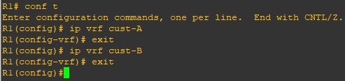

Step 3:- Configure interface addresses.

interface f0/0

ip vrf forwarding cust-A

ip address 10.10.10.1 255.255.255.0

no shutdown exit

interface S1/1

ip vrf forwarding cust-A

ip address 10.12.12.1 255.255.255.0

no shutdown

exit

interface f0/1

ip vrf forwarding cust-B

ip address 10.10.10.1 255.255.255.0

no shutdown

exit

interface S1/0

ip vrf forwarding cust-B

ip address 10.12.12.1 255.255.255.0

no shutdown

exit

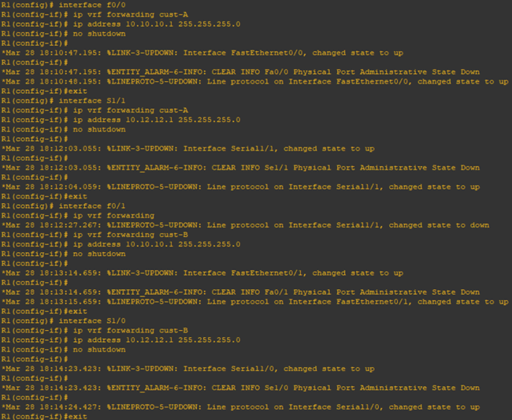

Router R2 Console

ip vrf cust-A exit

ip vrf cust-B exit

interface f0/0

ip vrf forwarding cust-A

ip address 10.20.20.2 255.255.255.0

no shutdown exit

interface S1/1

ip vrf forwarding cust-A

ip address 10.12.12.2 255.255.255.0

no shutdown exit

interface f0/1

ip vrf forwarding cust-B

ip address 10.20.20.2 255.255.255.0

no shutdown exit

interface S1/0

ip vrf forwarding cust-B

ip address 10.12.12.2 255.255.255.0

no shutdown exit

Router R3 Console

interface Loopback0

ip address 10.1.1.3 255.255.255.0 no shutdown

exit

interface f0/0

ip address 10.10.10.3 255.255.255.0

no shutdown

exit

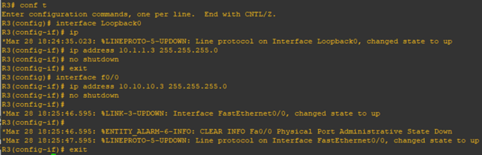

router eigrp 100

no auto

net 10.0.0.0

Router R4 Console

interface Loopback0

ip address 10.2.2.4 255.255.255.0

no shutdown

exit

interface f0/0

ip address 10.20.20.4 255.255.255.0

no shutdown

exit

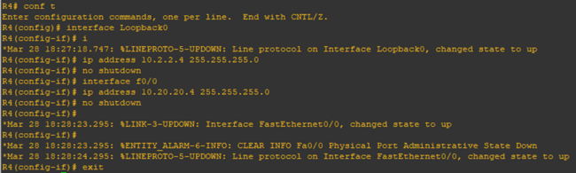

router eigrp 100 no auto

net 10.0.0.0



Router R5 Console

interface Loopback0

ip address 10.1.1.5 255.255.255.0

no shutdown

exit

interface f0/1

ip address 10.10.10.5 255.255.255.0

no shutdown

exit

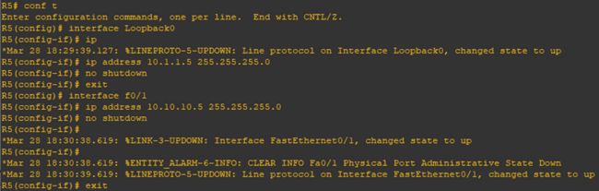

router eigrp 100

no auto

net 10.0.0.0

Router R6 Console

interface Loopback0

ip address 10.2.2.6 255.255.255.0

no shutdown

exit

interface f0/1

ip address 10.20.20.6 255.255.255.0

no shutdown

router eigrp 100

no auto

Router R1 Console

router eigrp 1

address-family ipv4 vrf cust-A autonomous-system 100

no auto

network 10.0.0.0

exit

address-family ipv4 vrf cust-B

autonomous-system 100

no auto

network 10.0.0.0

exit

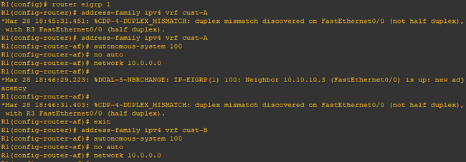

Router R1 Console

show ip route

Note:- Since we have configured virtual routing and forwarding it will not display the connections

To check the routes we have to write the following command. show ip route vrf cust-A

Note:- Now it will display all the connections.

Since we have configured virtual routing and forwarding on R1 and R2, to ping we have to write the following command.

ping vrf cust-A 10.1.1.3

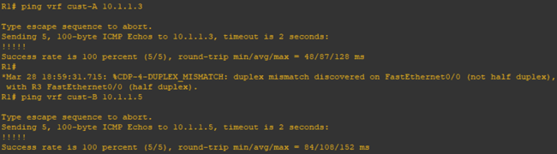

Router R3 Console

Since we have not configured virtual routing and forwarding on R3,R4,R5 and R6, to ping we simply have to write the following command.

ping 10.2.2.4

Practical 8

AIM: Simulating MPLS environment

Topology:

**Router R1 Console**

interface Loopback0

ip address 1.1.1.1 255.255.255.255

ip ospf 1 area 0

exit

interface f0/0

ip address 10.0.0.1 255.255.255.0

no shutdown

ip ospf 1 area

exit

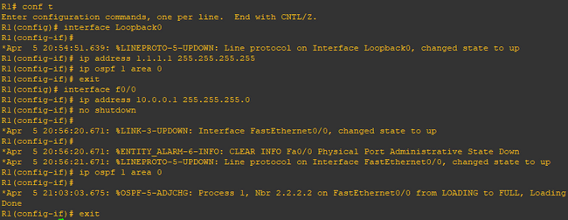

**Router R2 Console**

interface Loopback0

ip address 2.2.2.2 255.255.255.255

ip ospf 1 area 0

exit

interface f0/0

ip address 10.0.0.2 255.255.255.0

no shutdown

ip ospf 1 area 0

exit

interface f0/1

ip address 10.0.1.2 255.255.255.0

no shutdown

ip ospf 1 area 0

exit

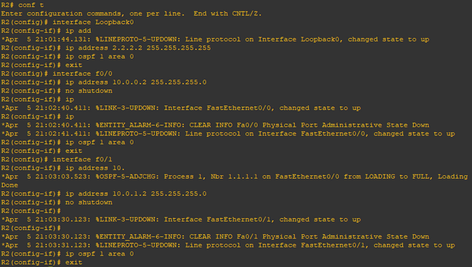

**Router R3 Console**

interface Loopback0

ip address 3.3.3.3 255.255.255.255

ip ospf 1 area 0

exit

interface f0/0

ip address 10.0.1.3 255.255.255.0

no shutdown

ip ospf 1 area 0

exit

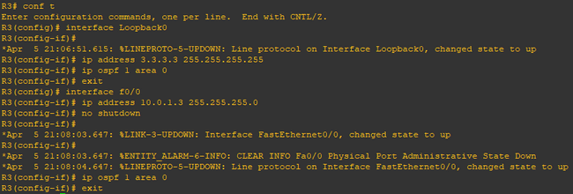

**Router R1 Console**

ping 3.3.3.3 source Loopback0

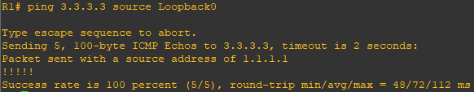

router ospf 1

mpls ldp autoconfig

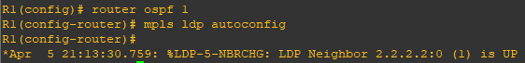

**Router R3 Console**

router ospf 1

mpls ldp autoconfig

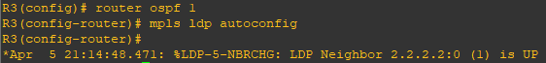

**Router R2 Console**

router ospf 1

mpls ldp autoconfig

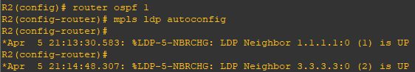

show mpls interface

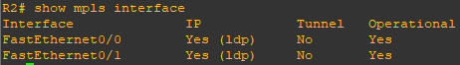

show mpls ldp neighbor

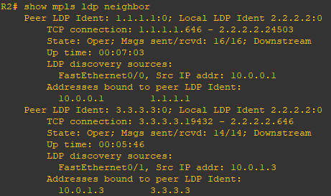

**Router R1 Console**

trace 3.3.3.3

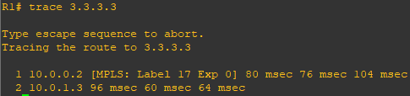

**Router R1 Console**

router bgp 1

neighbor 3.3.3.3 remote-as 1

neighbor 3.3.3.3 update-source Loopback0

no auto-summary

address-family vpnv4

neighbor 3.3.3.3 activate

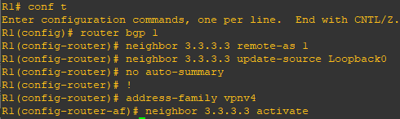

**Router R3 Console**

router bgp 1

neighbor 1.1.1.1 remote-as 1

neighbor 1.1.1.1 update-source Loopback0

no auto-summary

address-family vpnv4

neighbor 1.1.1.1 activate

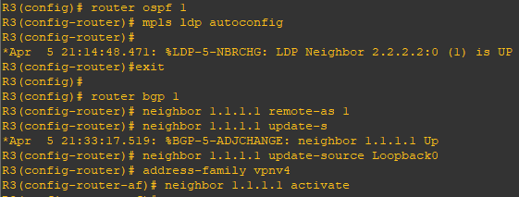

**Router R1 Console**

show bgp vpnv4 unicast all summary

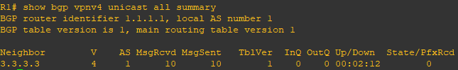

**Router R4 Console**

interface Loopback0

ip address 4.4.4.4 255.255.255.255

ip ospf 2 area 2

exit

interface f0/0

ip address 192.168.1.4 255.255.255.0

ip ospf 2 area 2

no shutdown

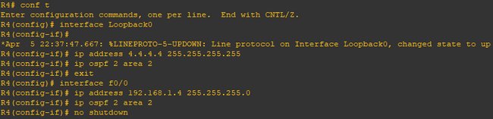

**Router R1 Console**

interface f0/1

ip address 192.168.1.1 255.255.255.0

no shutdown



**Router R1 Console**

ip vrf RED

rd 4:4

route-target both 4:4

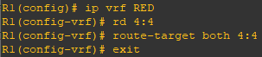

interface f0/1

ip vrf forwarding RED



interface f0/1

ip address 192.168.1.1 255.255.255.0

no shutdown



show run interface f0/1

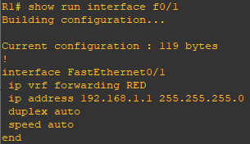

show ip route

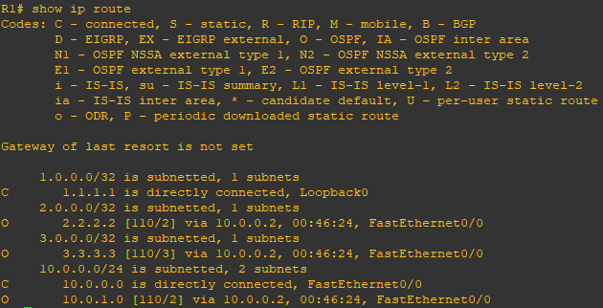

show ip route vrf RED

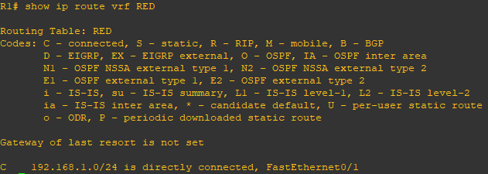

int f0/1

ip ospf 2 area 2

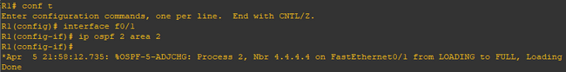

show ip route vrf RED

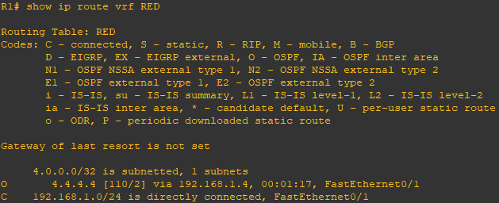

**Router R5 Console**

interface Loopback0

ip address 5.5.5.5 255.255.255.255

ip ospf 2 area 2

exit

interface f0/0

ip address 192.168.2.5 255.255.255.0

ip ospf 2 area 2

no shutdown

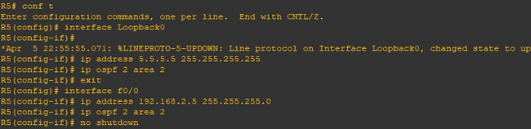

**Router R3 Console**

interface f0/1

ip address 192.168.2.3 255.255.255.0

no shutdown



ip vrf RED

rd 4:4

route-target both 4:4

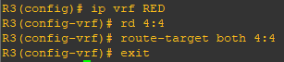

interface f0/1

ip vrf forwarding RED



interface f0/1

ip address 192.168.2.3 255.255.255.0

no shutdown

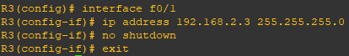

show run interface f0/1

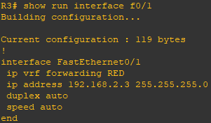

interface f0/1

ip ospf 2 area 2

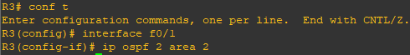

show ip route vrf RED

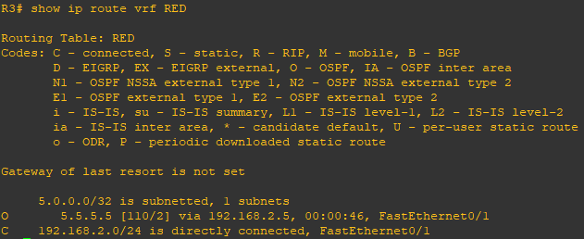

**Router R4 Console**

show ip route

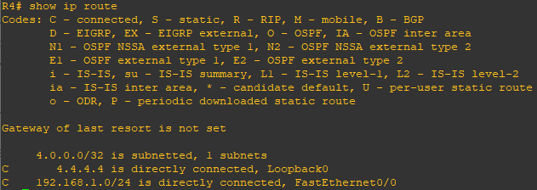

**Router R1 Console**

show ip route

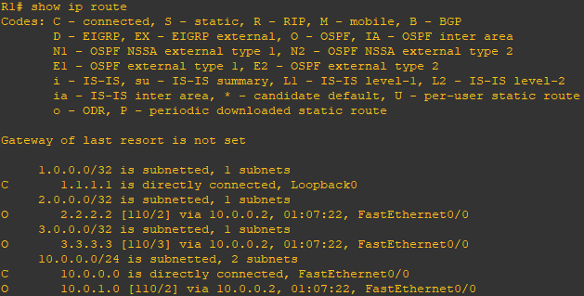

show ip route vrf RED

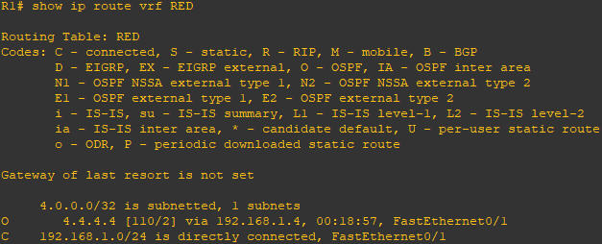

router bgp 1

address-family ipv4 vrf RED

redistribute ospf 2

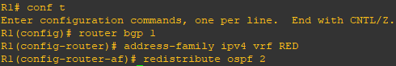

**Router R3 Console**

router bgp 1

address-family ipv4 vrf RED

redistribute ospf 2

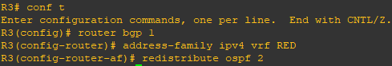

**Router R1 Console**

show ip bgp vpnv4 vrf RED

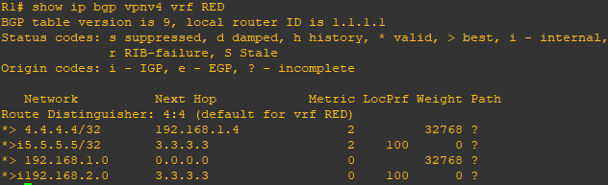

**Router R3 Console**

show ip bgp vpnv4 vrf RED

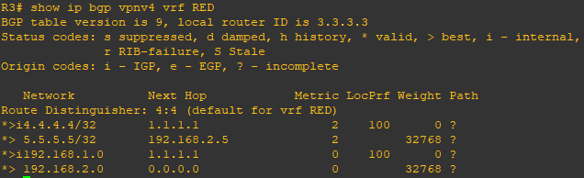

**Router R1 Console**

router ospf 2

redistribute bgp 1 subnets

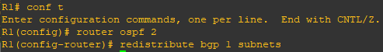

**Router R3 Console**

router ospf 2

redistribute bgp 1 subnets



**Router R4 Console**

show ip route

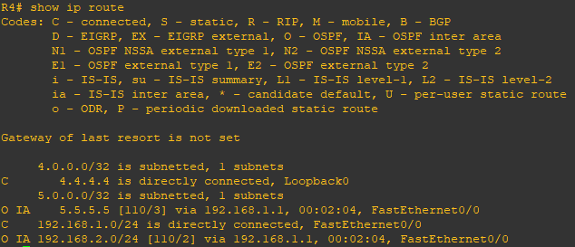

**Router R5 Console**

show ip route

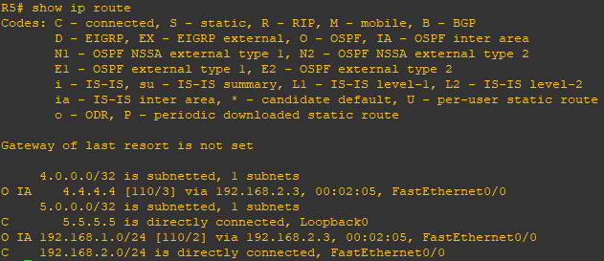

**Router R4 Console**

ping 5.5.5.5

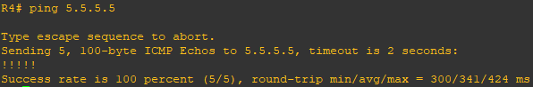

trace 5.5.5.5

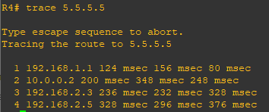

Practical 3

AIM: Configuring IBGP and EBGP Sessions, Local Preference, and MED

Topology:

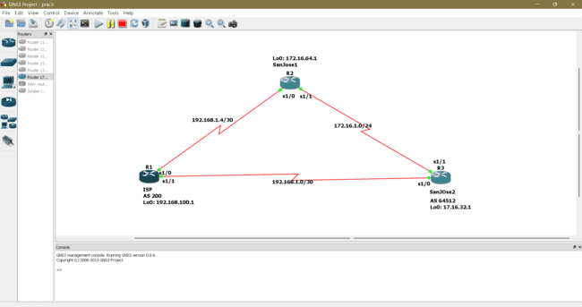

**Step 1: Configure interface addresses.**

a) Using the addressing scheme in the diagram, create the loopback interfaces and apply IPv4

addresses to these and the serial interfaces on ISP (R1), SanJose1 (R2), and SanJose2 (R3).

Apply the following configuration to each router along with the appropriate hostname.

**Router R1 Console (hostname ISP)**

hostname ISP

interface Loopback0

ip address 192.168.100.1 255.255.255.0

exit

interface s1/0

ip address 192.168.1.5 255.255.255.252

clock rate 128000

no shutdown

exit

interface s1/1

ip address 192.168.1.1 255.255.255.252

no shutdown

exit

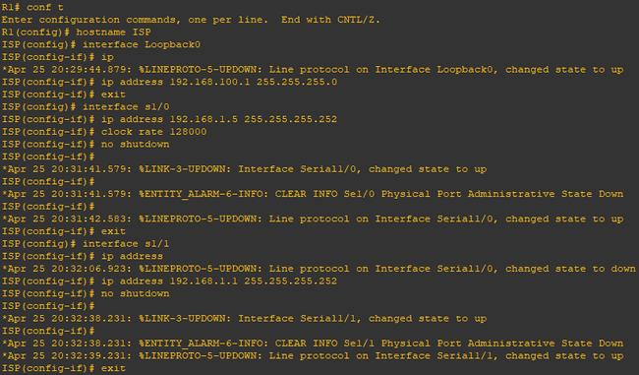

**Router R2 Console (hostname SanJose1)**

hostname SanJose1

interface Loopback0

ip address 172.16.64.1 255.255.255.0

exit

interface s1/0

ip address 192.168.1.6 255.255.255.252

no shutdown

exit

interface s1/1

ip address 172.16.1.1 255.255.255.0

clock rate 128000

no shutdown

exit

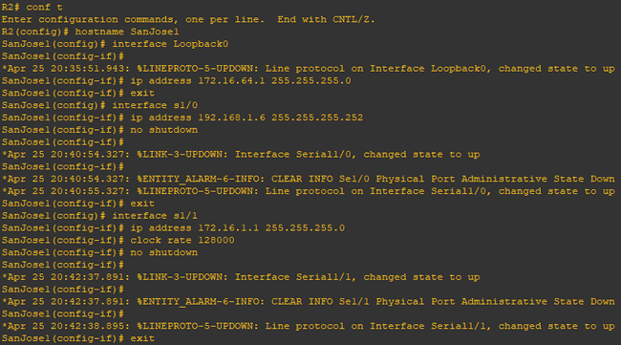

**Router R3 Console (hostname SanJose2)**

hostname SanJose2

interface Loopback0

ip address 172.16.32.1 255.255.255.0

exit

interface s1/0

ip address 192.168.1.2 255.255.255.252

clock rate 128000

no shutdown

exit

interface s1/1

ip address 172.16.1.2 255.255.255.0

no shutdown

exit

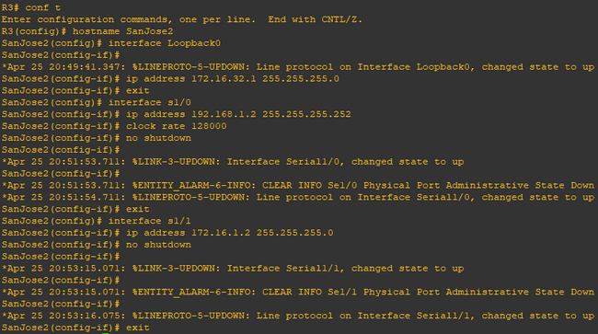

**Step 2: Configure EIGRP.**

Configure EIGRP between the SanJose1 and SanJose2 routers. (Note: If using an IOS prior to

15.0, use the no auto-summary router configuration command to disable automatic

summarization. This command is the default beginning with IOS 15.)

**Router R2 Console (hostname SanJose1)**

router eigrp 1

network 172.16.0.0



**Router R3 Console (hostname SanJose2)**

router eigrp 1

network 172.16.0.0



**Step 3: Configure IBGP and verify BGP neighbors.**

a) Configure IBGP between the SanJose1 and SanJose2 routers.

**Router R2 Console (hostname SanJose1)**

router bgp 64512

neighbor 172.16.32.1 remote-as 64512

neighbor 172.16.32.1 update-source Loopback0



**Router R3 Console (hostname SanJose2)**

router bgp 64512

neighbor 172.16.64.1 remote-as 64512

neighbor 172.16.64.1 update-source Loopback0

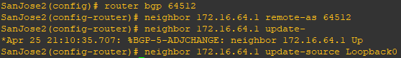

show ip bgp neighbors

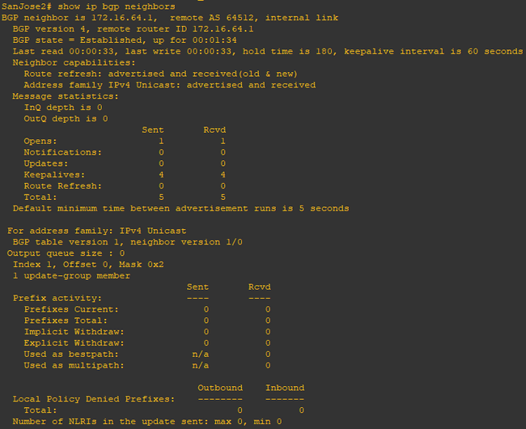

**Step 4: Configure EBGP and verify BGP neighbors.**

a) Configure ISP to run EBGP with SanJose1 and SanJose2. Enter the following commands

on ISP.

**Router R1 Console (hostname ISP)**

router bgp 200

neighbor 192.168.1.6 remote-as 64512

neighbor 192.168.1.2 remote-as 64512

network 192.168.100.0

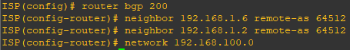

b) Configure a discard static route for the 172.16.0.0/16 network. Any packets that do not

have a more specific match (longer match) for a 172.16.0.0 subnet will be dropped instead of

sent to the ISP. Later in this lab we will configure a default route to the ISP.

**Router R2 Console (hostname SanJose1)**

ip route 172.16.0.0 255.255.0.0 null0

c) Configure SanJose1 as an EBGP peer to ISP.

**Router R2 Console (hostname SanJose1)**

router bgp 64512

neighbor 192.168.1.5 remote-as 200

network 172.16.0.0

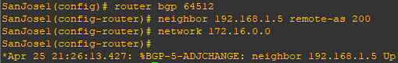

d) Use the show ip bgp neighbors command to verify that SanJose1 and ISP have reached the

established state. Troubleshoot if necessary.

**Router R2 Console (hostname SanJose1)**

show ip bgp neighbors

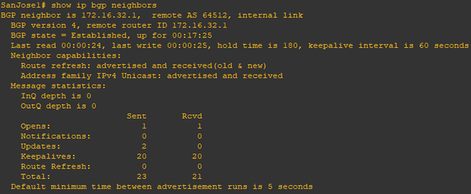

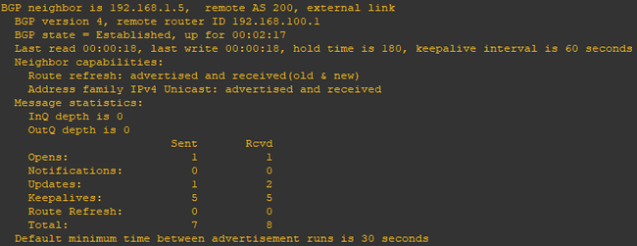

**Router R3 Console (hostname SanJose2)**

ip route 172.16.0.0 255.255.0.0 null0

router bgp 64512

neighbor 192.168.1.1 remote-as 200

network 172.16.0.0

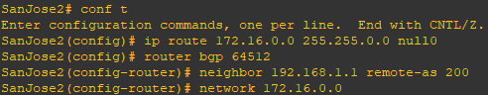

**Step 5: View BGP summary output.**

**Router R2 Console (hostname SanJose2)**

show ip bgp summary

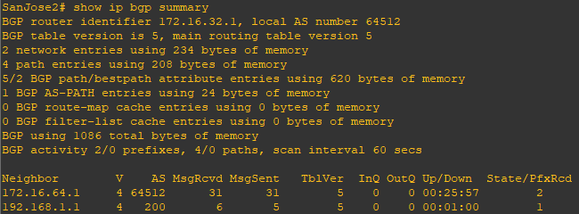

**Step 6: Verify which path the traffic takes.**

**Router R1 Console (hostname ISP)**

clear ip bgp *

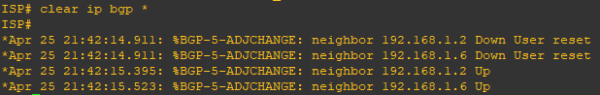

ping 172.16.64.1

ping 172.16.1.1

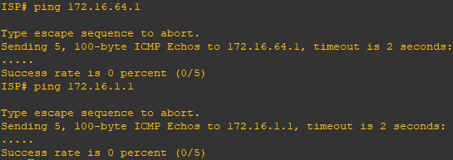

ping 172.16.32.1

ping 172.16.1.2

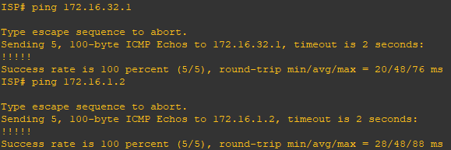

show ip bgp

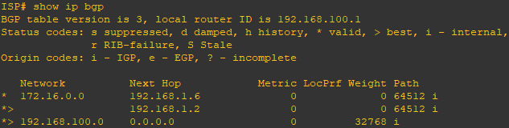

ping 172.16.1.1 source 192.168.100.1

ping 172.16.32.1 source 192.168.100.1

ping 172.16.1.2 source 192.168.100.1

ping 172.16.64.1 source 192.168.100.1

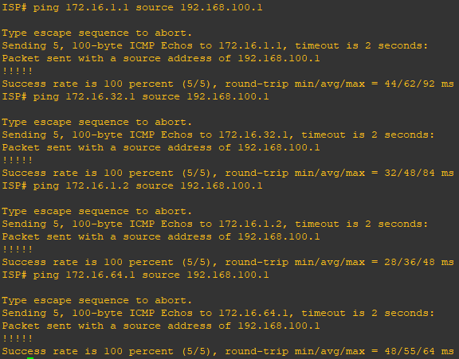

ping

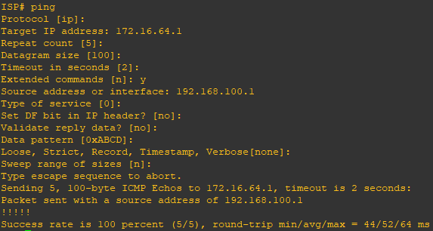

**Step 7: Configure the BGP next-hop-self feature.**

**Router R1 Console (hostname ISP)**

a) Issue the following commands on the ISP router.

router bgp 200

network 192.168.1.0 mask 255.255.255.252

network 192.168.1.4 mask 255.255.255.252

end

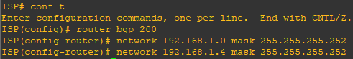

b) Issue the show ip bgp command to verify that the ISP is correctly injecting its own WAN links into BGP.

show ip bgp

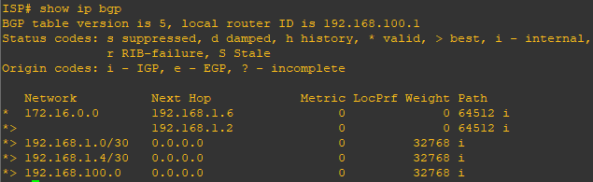

c) Verify on SanJose1 and SanJose2 that the opposite WAN link is included in the routing table. The output from SanJose2 is as follows.

**Router R3 Console (hostname SanJose2)**

show ip route

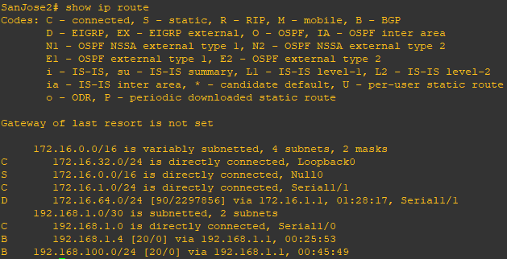

d) To better understand the next-hop-self command we will remove ISP advertising its two WAN links and shutdown the WAN link between ISP and SanJose2. The only possible path from SanJose2 to ISP’s 192.168.100.0/24 is through SanJose1.

**Router R1 Console (hostname ISP)**

router bgp 200

no network 192.168.1.0 mask 255.255.255.252

no network 192.168.1.4 mask 255.255.255.252

exit

interface s1/1

shutdown

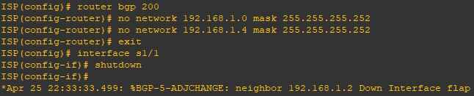

e) Display SanJose2’s BGP table using the show ip bgp command and the IPv4 routing table with show ip route.

**Router R3 Console (hostname SanJose2)**

show ip bgp

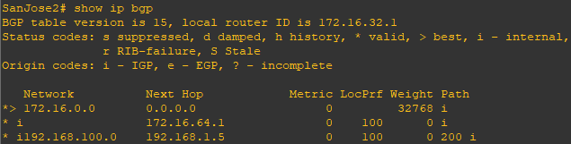

show ip route

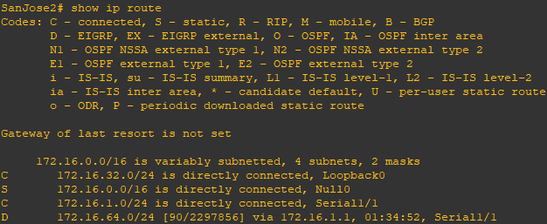

f) Issue the next-hop-self command on SanJose1 and SanJose2 to advertise themselves as the next hop to their IBGP peer.

**Router R2 Console (hostname SanJose1)**

router bgp 64512

neighbor 172.16.32.1 next-hop-self

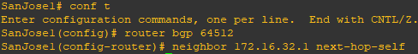

**Router R3 Console (hostname SanJose2)**

router bgp 64512

neighbor 172.16.64.1 next-hop-self

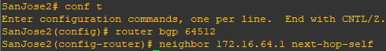

g) Reset BGP operation on either router with the clear ip bgp * command.

**Router R2 Console (hostname SanJose1)**

clear ip bgp *

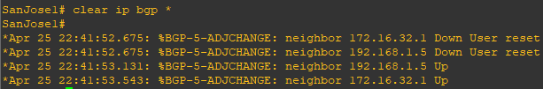

**Router R3 Console (hostname SanJose2)**

clear ip bgp *

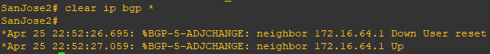

h) After the routers have returned to established BGP speakers, issue the show ip bgp command on SanJose2 and notice that the next hop is now SanJose1 instead of ISP.

**Router R3 Console (hostname SanJose2)**

show ip bgp

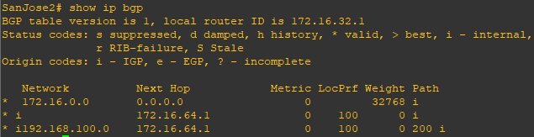

i) The show ip route command on SanJose2 now displays the 192.168.100.0/24 network because SanJose1 is the next hop, 172.16.64.1, which is reachable from SanJose2.

**Router R3 Console (hostname SanJose2)**

show ip route

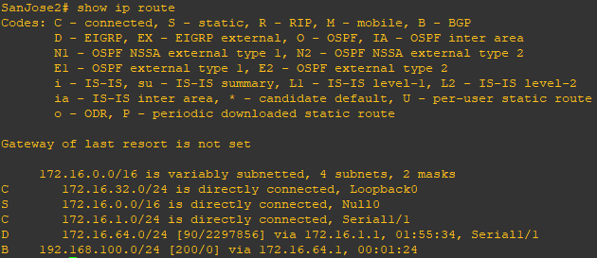

j) Before configuring the next BGP attribute, restore the WAN link between ISP and SanJose3. This will change the BGP table and routing table on both routers. For example, SanJose2’s routing table shows 192.168.100.0/24 will now have a better path through ISP.

**Router R1 Console (hostname ISP)**

interface s1/1

no shutdown

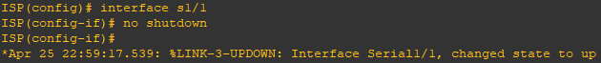

**Router R3 Console (hostname SanJose2)**

show ip route

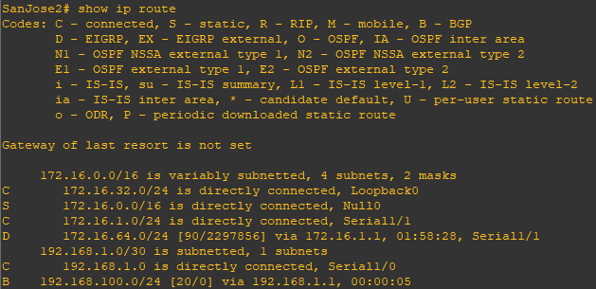

**Step 8: Set BGP local preference.**

At this point, everything looks good, with the exception of default routes, the outbound flow of data, and inbound packet flow.

a) Because the local preference value is shared between IBGP neighbors, configure a simple route map that references the local preference value on SanJose1 and SanJose2. This policy adjusts outbound traffic to prefer the link off the SanJose1 router instead of the metered T1 off SanJose2.

**Router R2 Console (hostname SanJose1)**

route-map PRIMARY_T1_IN permit 10

set local-preference 150

exit

router bgp 64512

neighbor 192.168.1.5 route-map PRIMARY_T1_IN in

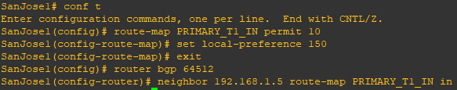

**Router R3 Console (hostname SanJose2)**

route-map SECONDARY_T1_IN permit 10

set local-preference 125

exit

router bgp 64512

neighbor 192.168.1.1 route-map SECONDARY_T1_IN in

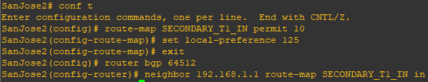

b) Use the clear ip bgp * soft command after configuring this new policy. When the conversations have been reestablished, issue the show ip bgp command on SanJose1 and SanJose2.

**Router R2 Console (hostname SanJose1)**

clear ip bgp * soft

show ip bgp

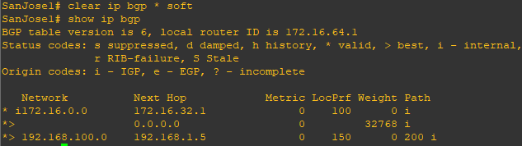

**Router R3 Console (hostname SanJose2)**

clear ip bgp * soft

show ip bgp

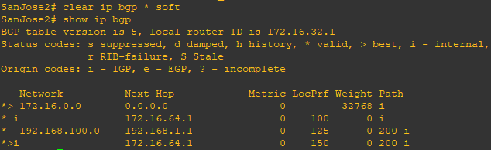

**Step 9: Set BGP MED.**

a) In the previous step we saw that SanJose1 and SanJose2 will route traffic for 192.168.100.0/24 using the link between SanJose1 and ISP. Examine what the return path ISP takes to reach AS 64512. Notice that the return path is different from the original path. This is known as asymmetric routing and is not necessarily an unwanted trait.

**Router R1 Console (hostname ISP)**

show ip bgp

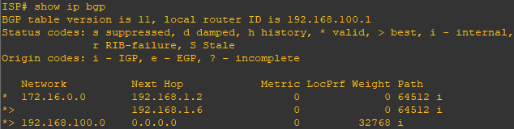

show ip route

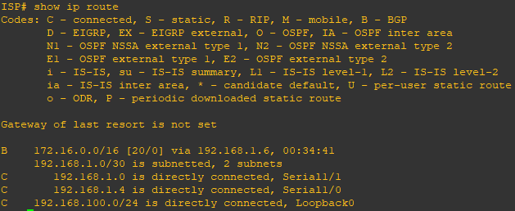

b) Use an extended ping command to verify this situation. Specify the record option and compare your output to the following. Notice the return path using the exit interface 192.168.1.1 to SanJose2.

**Router R3 Console (hostname SanJose2)**

ping

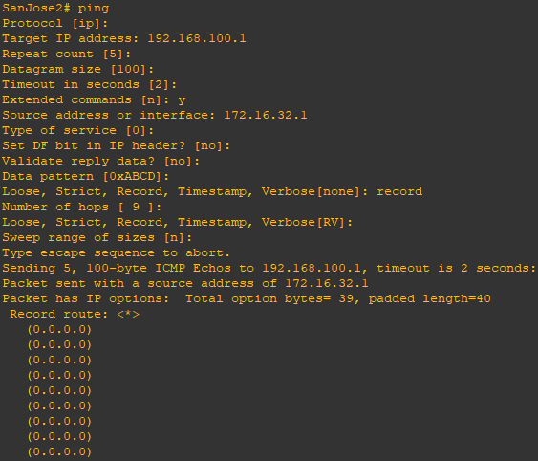

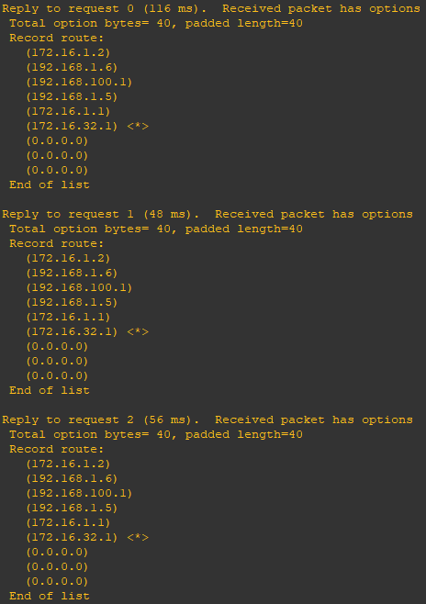

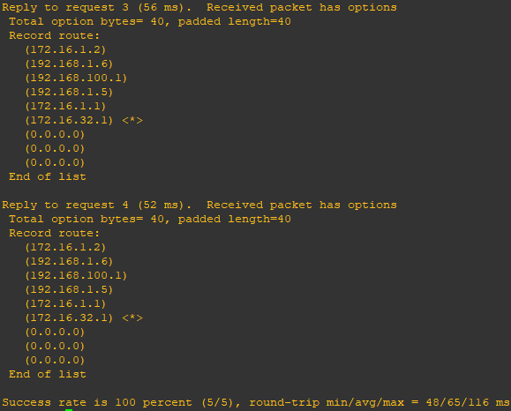

c) Create a new policy to force the ISP router to return all traffic via SanJose1. Create a second route map utilizing the MED (metric) that is shared between EBGP neighbors.

**Router R2 Console (hostname SanJose1)**

route-map PRIMARY_T1_MED_OUT permit 10

set Metric 50

exit

router bgp 64512

neighbor 192.168.1.5 route-map PRIMARY_TI_MED_OUT out

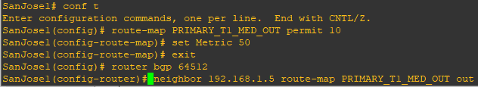

**Router R3 Console (hostname SanJose2)**

route-map SECONDARY_T1_MED_OUT permit 10

set Metric 75

exit

router bgp 64512

neighbor 192.168.1.1 route-map SECONDARY_T1_MED_OUT out

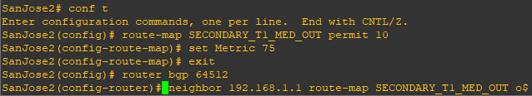

d) Use the clear ip bgp * soft command after issuing this new policy. Issuing the show ip bgp command as follows on SanJose1 or SanJose2 does not indicate anything about this newly defined policy.

**Router R2 Console (hostname SanJose1)**

clear ip bgp * soft

show ip bgp

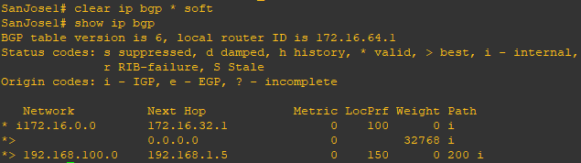

**Router R3 Console (hostname SanJose2)**

clear ip bgp * soft

show ip bgp

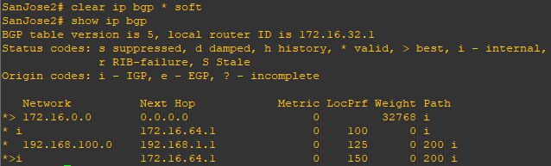

e) Reissue an extended ping command with the record command. Notice the change in return path using the exit interface 192.168.1.5 to SanJose1.

**Router R3 Console (hostname SanJose2)**

ping



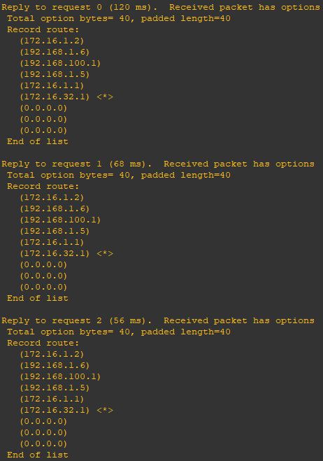

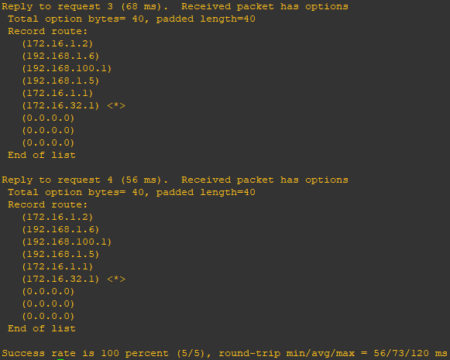

**Step 10: Establish a default route.**

The final step is to establish a default route that uses a policy statement that adjusts to changes in the network.

a) Configure ISP to inject a default route to both SanJose1 and SanJose2 using BGP using the default-originate command. This command does not require the presence of 0.0.0.0 in the ISP router. Configure the 10.0.0.0/8 network which will not be advertised using BGP. This network will be used to test the default route on SanJose1 and SanJose2.

**Router R1 Console (hostname ISP)**

show ip bgp

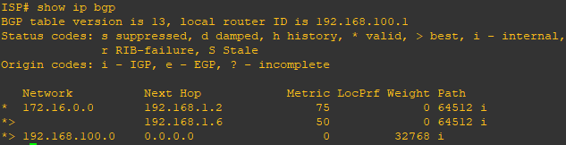

router bgp 200

neighbor 192.168.1.6 default-originate

neighbor 192.168.1.2 default-originate

exit

interface loopback 10

ip address 10.0.0.1 255.255.255.0

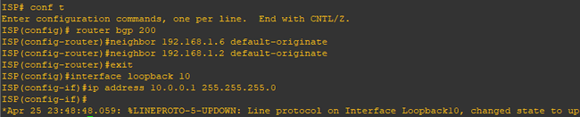

b) Verify that both routers have received the default route by examining the routing tables on SanJose1 and SanJose2. Notice that both routers prefer the route between SanJose1 and ISP.

**Router R2 Console (hostname SanJose1)**

show ip route

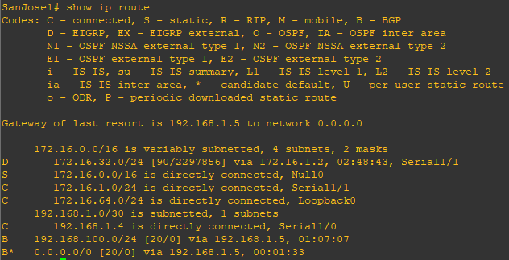

**Router R3 Console (hostname SanJose2)**

show ip route

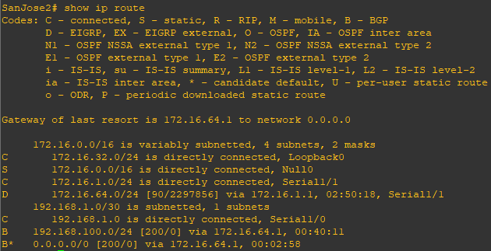

c) The preferred default route is by way of SanJose1 because of the higher local preference attribute configured on SanJose1 earlier.

**Router R3 Console (hostname SanJose2)**

show ip bgp

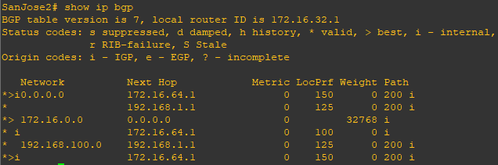

d) Using the traceroute command verify that packets to 10.0.0.1 is using the default route through SanJose1.

**Router R3 Console (hostname SanJose2)**

traceroute 10.0.0.1

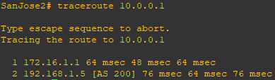

e) Next, test how BGP adapts to using a different default route when the path between SanJose1 and ISP goes down.

**Router R1 Console (hostname ISP)**

interface s1/0

shutdown

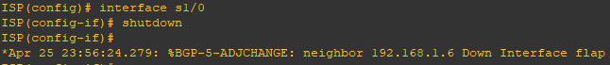

f) Verify that both routers are modified their routing tables with the default route using the path between SanJose2 and ISP.

**Router R2 Console (hostname SanJose1)**

show ip route

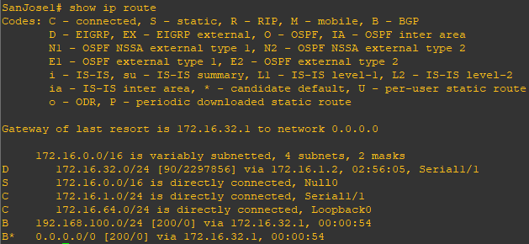

**Router R3 Console (hostname SanJose2)**

show ip route

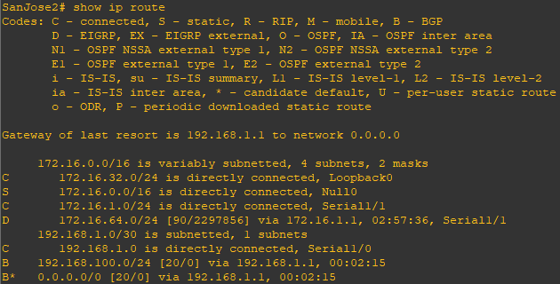

g) Verify the new path using the traceroute command to 10.0.0.1 from SanJose1. Notice the default route is now through SanJose2.

**Router R2 Console (hostname SanJose1)**

traceroute 10.0.0.1

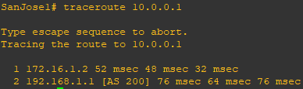

Practical 6

AIM: To Simulate IP Service Level Agreements and Remote SPAN in a Campus Environment

Topology

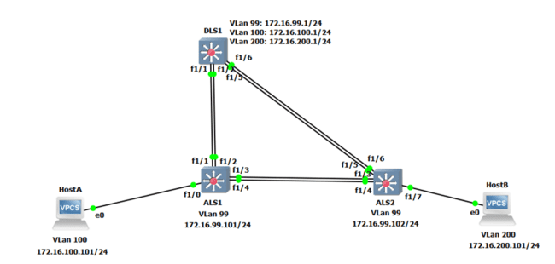

**Part 1: Prepare for the Lab**

**Step 1: Configure basic switch parameters.**

Configure an IP address on the management VLAN according to the diagram. VLAN 1 is the default management VLAN, but following best practice, we will use a different VLAN. In this case, VLAN 99.

Enter basic configuration commands on each switch according to the diagram.

**DSL1 Console:**

interface vlan 99

ip address 172.16.99.1 255.255.255.0

no shutdown

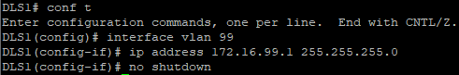

enable secret password

line vty 0 15

no login

privilege level 15

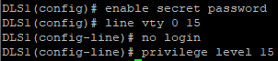

**ALS1 Console:**

interface vlan 99

ip address 172.16.99.1 255.255.255.0

no shutdown

exit

enable secret password

line vty 0 15

no login

privilege level 15

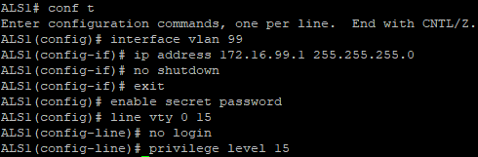

**ALS2 Console:**

interface vlan 99

ip address 172.16.99.1 255.255.255.0

no shutdown

exit

enable secret password

line vty 0 15

no login

privilege level 15

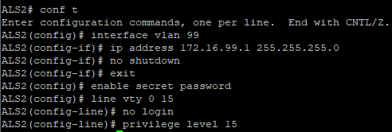

Configure default gateways on ALS1 and ALS2. These are access layer switches operating as Layer 2 devices and need a default gateway to send traffic from their management interface to other networks. Configure both ALS1 and ALS2.

**ALS1 Console:**

ip default-gateway 172.16.99.1

**ALS2 Console:**

ip default-gateway 172.16.99.1

**Step 2: Configure host PCs.**

Configure PCs Host A and Host B with the IP address and subnet mask shown in the topology. Host A is in VLAN 100 with a default gateway of 172.16.100.1. Host B is in VLAN 200 with a default gateway of 172.16.200.1.

**hostA Console:**

ip 172.16.100.101/24 172.16.100.1



**hostB Console:**

ip 172.16.200.101/24 172.16.200.1

**Step 3: Configure trunks and EtherChannels between switches.**

Configure the trunks and EtherChannel from DLS1 to ALS1

**DLS1 Console:**

interface ran f 1/1 – 2

switchport trunk encapsulation dot1q

switchport mode trunk

channel-group 1 mode on

no shutdown

exit

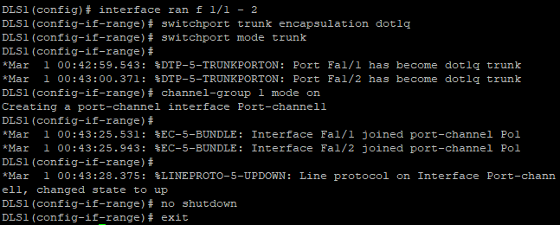

Configure the trunks and EtherChannel from DLS1 to ALS2

**DLS1 Console:**

interface ran f 1/5 – 6

switchport trunk encapsulation dot1q

switchport mode trunk

channel-group 2 mode on

no shutdown

exit

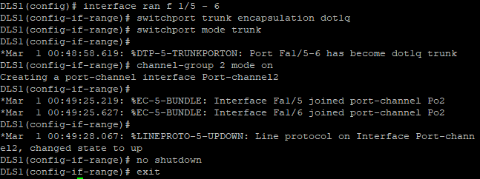

Configure the trunks and EtherChannel from ALS1 and DLS1

**ALS1 Console:**

interface range f 1/3 – 4

switchport mode trunk

channel-group 3 mode on

no shutdown

exit

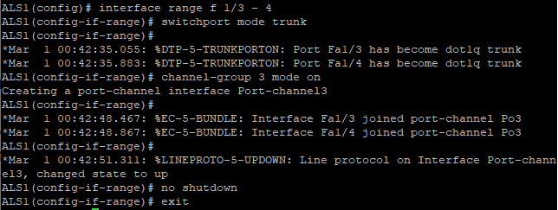

Configure the trunks and EtherChannel from ALS1 and ALS2

**ALS1 Console:**

interface range f 1/1 – 2

switchport mode trunk

channel-group 2 mode on

no shutdown

exit

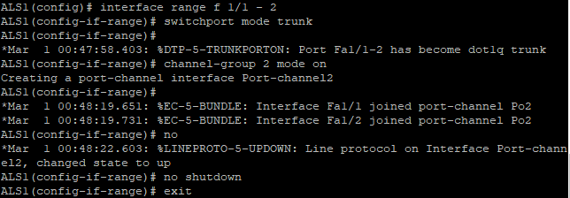

Configure the trunks and EtherChannel from ALS2 and DLS1

**ALS2 Console:**

interface range f 1/3 – 4

switchport mode trunk

channel-group 3 mode on

no shutdown

exit

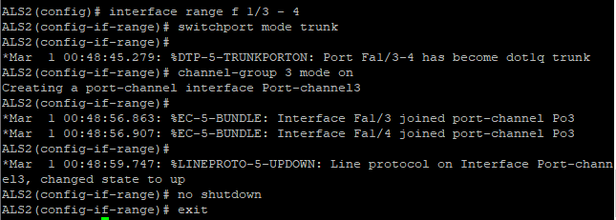

Configure the trunks and EtherChannel from ALS2 and ALS1

interface range f 1/5 – 6

switchport mode trunk

channel-group 2 mode on

no shutdown

exit

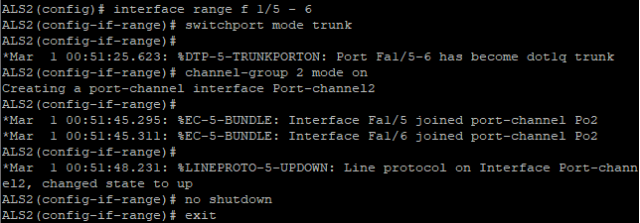

Practical 7

AIM: Inter-VLAN Routing

Topology:

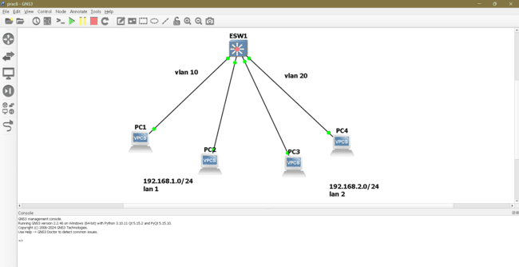

pc1> ip 192.168.1.1/24



PC2> ip 192.168.1.2/24

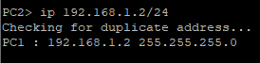

PC3> ip 192.168.2.1



PC4> ip 192.168.2.2/24



ESW1#vlan database

ESW1(vlan)#vlan 10

ESW1(vlan)#vlan 20

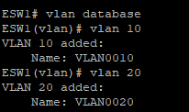

ESW1#show vlan-switch

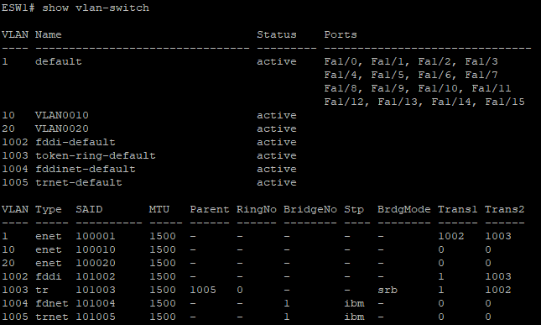

ESW1#conf t

interface f1/0

switchport mode access

switchport access vlan 10

exit

interface f1/1

switchport mode access

switchport access vlan 10

exit

interface f1/2

switchport mode access

switchport access vlan 10

exit

interface f1/3

switchport mode access

switchport access vlan 10

exit

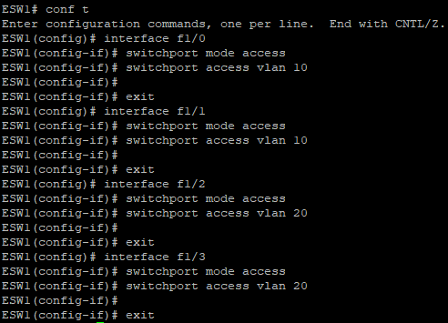

ESW1#show vlan-switch

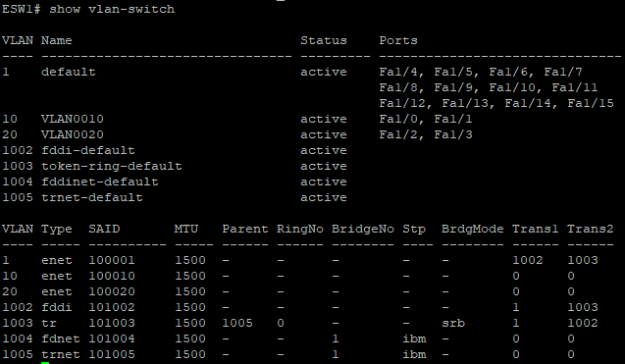

PC1> ping 192.168.1.2

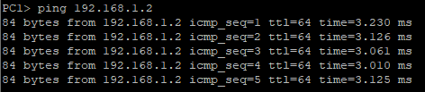

PC1> ping 192.168.2.1



PC1> show ip

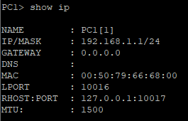

PC1> ip 192.168.1.1/24 192.168.1.254

PC1> show ip

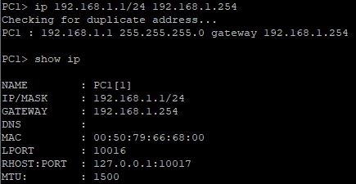

PC2> ip 192.168.1.2/24 192.168.1.254

PC2> show ip

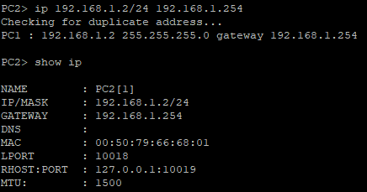

PC3> ip 192.168.2.1/24 192.168.2.254

PC3> show ip

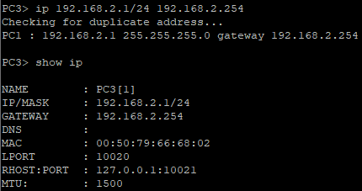

PC4> ip 192.168.2.2/24 192.168.2.254

PC4> show ip

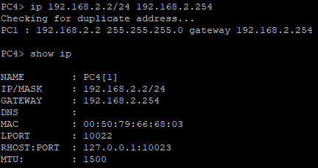

ESW1#conf t

interface vlan 10

ip address 192.168.1.254 255.255.255.0

no shut

exit

interface vlan 20

ip address 192.168.2.254 255.255.255.0

no shut

exit

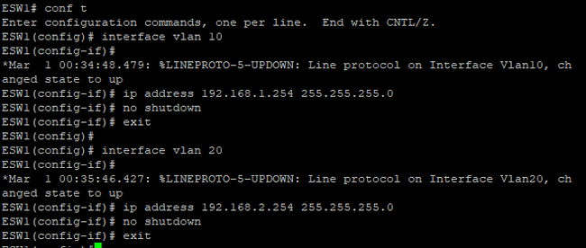

ESW1#conf t

ESW1(config)#ip routing

ESW1(config)#end

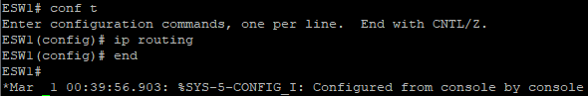

Show ip route

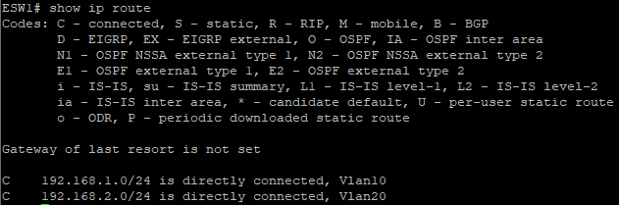

pc1>ping 192.168.2.1

pc1>ping 192.168.2.2

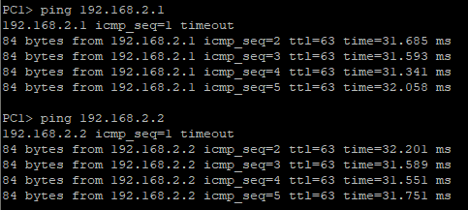

pc4>ping 192.168.1.1

pc4>ping 192.168.1.2